**Guidewire important Questions with Answers:**

**Claim Center:**

Guidewire Claim Center is a claims management system designed for property and casualty (P&C) insurance companies. It helps insurers streamline and automate the claims process, from first notice of loss (FNOL) to settlement. Claim Center improves efficiency, reduces operational costs, and enhances customer service by offering features like workflow automation, fraud detection, and integration with third-party systems.

**Claim Center**:

* Focuses on managing and processing insurance claims.
* Handles claim intake, assessment, payments, and fraud detection.
* Ensures compliance and automates claims workflows.

**Policy Center**:

* Manages policy administration, including policy creation, endorsements, renewals, and cancellations.
* Supports underwriting, risk assessment, and quote generation.
* Helps insurers manage customer policies effectively.

**Billing Center**:

* Handles premium billing, invoicing, and payments.
* Manages payment plans, commissions, and delinquency processing.
* Ensures smooth financial transactions between insurers, agents, and policyholders.

| **Feature** | **Claim Center** | **Policy Center** | **Billing Center** |
| --- | --- | --- | --- |
| Purpose | Manages insurance claims | Manages policy lifecycle | Manages premium billing & payments |
| Users | Adjusters, claims handlers | Underwriters, agents | Finance & accounting teams |
| Functionality | FNOL, claim assessment, settlements | Policy issuance, endorsements, renewals | Premium billing, invoicing, collections |
| Integration | Connects with Policy Center & Billing Center | Links to underwriting and claims | Works with Policy Center & Claim Center for payments |

1. **Data Modal:**

The data model is the description of the database representation of all data entities and their

attributes, and the relationships between them that define how claim-related information is

stored and managed.

1. **What are all the three types of Entities?**

**Entity** is the data object that represent items such as policies, claims, accounts and payments.

Each entity has some set of attributes and behaviors.

Entity has the files like eti, etx, eix files.

* **eti** is Read only file given by Guidewire tool.
* **etx** is the extensions of .eti file. If we need to add anything, edit or make changes in the existing column.
* **eix** is already extended by guidewire and we could not extend additionally.

1. **What is typelist?**

Guidewire Claim Center displays many fields in the interface as drop-down lists of possible values. The list of available values for a drop-down field is called a typelist. Typelists limit the acceptable values for many fields within the application. Thus, a typelist represents a predefined set of possible values, with each separate value defined as a typecode. Whenever there is a drop-down list in the ClaimCenter interface, it is usually a typelist.

**Typelist** has the. tti,. ttx and .tix file.

These files also doing same as the entity extension files.

If you need to introduce new typelist or entity in guidewire we have some naming conventions like, amount_etx or Ext_amount (follow by the typelist/entity name).

**Type list** are stored as database tables.  
**Type codes** are stored as rows in the table.  
**Type key** is stored as foreign key columns in the entity table.  
A **type filter** defines a named subset of the type codes that could be used as value for the associated type key field that references this type list.

**3.What is type filter?**

Type Filter is a configuration element used to filter lists of entities (such as claims, policies, or exposures) based on specific criteria. It allows you to define conditions that determine which entities should be included or excluded in a particular context. Type Filters are commonly used in Dropdowns, Picker controls, or other UI elements where you need to display a filtered list of items.

**Steps:**

1. Go to the typelist where you can add the typefilter.

2. Click on typefilter and choose type of typefilter you want.

3. Create typefilter.

**Category:**

The Category defines the type of entity or data that the TypeFilter applies to. It specifies the context in which the filter will operate.

**Example:**

If you are filtering claims, the category might be Claim. If you are filtering policies, the category might be Policy.

**Include:**

The Include element specifies the conditions under which an entity should be included in the filtered list. It defines the criteria that must be met for an entity to pass the filter.

**Example:**

If you want to include only claims with a specific loss type (e.g., Auto), you would define this condition in the Include section.

**Exclude:**

The Exclude element specifies the conditions under which an entity should be excluded from the filtered list. It defines the criteria that, if met, will cause an entity to be filtered out.

**Example:**

If you want to exclude claims that are closed, you will define this condition in the Exclude section.

**5. What is type category?**

It's used for **grouping values together** under a common category.

**Example:**

* Pollution or Fire loss causes Auto, GL, PR.

**6. What is the batch process?**

A batch process refers to the execution of a background job or task that processes large volumes of data in a non-interactive and automated manner. Batch processes are designed for tasks that do not require immediate user interaction and can run periodically or on-demand to manage system data, perform maintenance, and handle integrations efficiently.

1. **Schedulable:**

It means the process runs **automatically** at a **fixed time or interval** (daily, weekly, monthly, etc.). Report generation every Sunday.

1. **API Runnable:**

Means the process can be triggered **via an external system** using **Web Services / REST API**. External billing system triggers a claim export job using an API.

1. **UI Runnable:**

Means the job can be **manually run by a user** from the **Claim Center UI** (usually under Admin → Batch Processes). Admin manually runs “Archive Old Claims” from the Batch Process screen.

**What is the Work Queue:**

A **Work Queue** is also a background job to process many small, independent tasks in parallel, like sending notifications or recalculating fields. It provides better scalability and performance for concurrent workloads. It is **used when a large set of independent tasks (Work items)** need to be executed (like sending many emails, recalculating scores, etc.).

**Writer**

A writer thread does the following:

* It selects units of work for processing.
* It writes the identities of the work items to a work queue table.
* It notifies the workers that there are work items to process.

**Worker**

A worker retrieves or more work items from the work queue and processes the work items to completion. A worker only processes work items from its associated writer. By default, each work queue starts a single worker on each cluster member with the work queue role, unless configured otherwise.

**Executor**

The work queue executor manages the worker tasks on each application server in a Claim Center cluster. If a work queue has no more remaining items to process, the executor shuts down all workers on a server node except for one, which periodically checks to see if there is new work to perform.

**7. Difference between batch and work queue?**

|  |  |  |
| --- | --- | --- |
| **Aspect** | **Batch Process** | **Work Queue** |
| Definition | |  | | --- | |  |  |  | | --- | | Processes large datasets in bulk. | | Splits tasks into smaller units for parallel execution. |
| Execution | |  | | --- | |  |  |  | | --- | | Sequential or scheduled job. | | Dynamic, parallelized tasks within a batch process. |
| Purpose | |  | | --- | |  |  |  | | --- | | Handles system-wide bulk operations. | | Enhances performance by distributing workload. |
| Parallelism | May support limited parallelism. | Designed for high parallelism and scalability. |
| Fault Tolerance | Requires explicit implementation for retries. | Build-in retry mechanisms for failed tasks. |
| Scalability | |  | | --- | |  |  |  | | --- | | Limited by job configuration and resources. | | Highly scalable with distributed processing. |
| Use Cases | Reindexing, purging, reporting. | Processing claims, policies, or transactions. |
| Logging | |  | | --- | | Logs overall job progress. |  |  | | --- | |  | | Logs details of each individual task. |

**8. Create Entity and Typelist?**

**Entity:**

1. Open Guidewire Studio.
2. In the Studio Project window, expand configuration > config > Extensions.
3. Select Entity and right-click to open the context menu.
4. Select New > Entity.
5. In the Entity dialog, enter the information and press OK.

**Typelist:**

1. Open Guidewire Studio.
2. In the Studio Project window, expand configuration > config > Extensions.
3. Select Typelist and right-click to open the context menu.
4. Select New > Typelist.
5. In the Typelist dialog, enter the information and press OK.

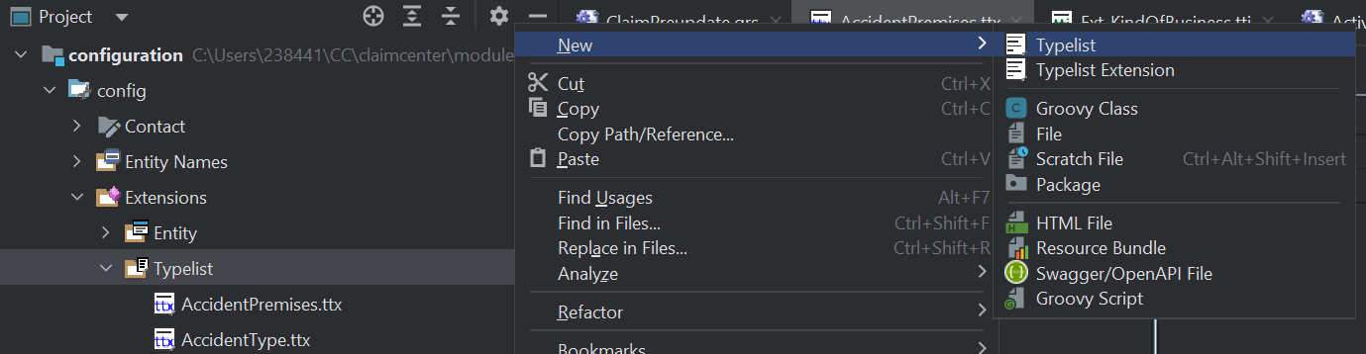

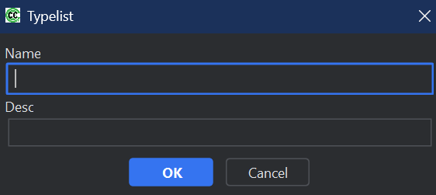

**8. How to extend Entity?**

**1. Locate the Entity to Extend**

* Identify the entity you want to extend (e.g., Claim, Policy, Exposure, etc.).
* Entity files are located in the configuration > config > Extensions directory with the .eti extension.

**2. Create an Extension File**

* Navigate to the configuration > config > Extensions directory in your studio.
* Create an .etx file for the entity you wish to extend. The naming convention is <EntityName>.etx (e.g., Claim.etx).

**9. What is Pop Up?**

pop-up is a smaller window or dialog box that appears in the user interface, typically to

display additional information or provide an input form without navigating away from the

current page.

**10. Queue:**

* A place for unassigned activities to wait until they are assigned to someone.
* A Queue defined on a parent group can be made visible to all child groups so that users of the parent and child groups can all access activities on the queue.
* Group members with the necessary permissions can assign activities from the queues to themselves or to other users.
* Activities assigned to Queue by automatically by rules activity.AssignedQueue. , manually using manual assignment in CC.

**11. LOB flow:**

**Loss Type** refers to the category or classification of a loss event associated with an insurance claim. It provides a way to identify the specific nature of the damage or incident, helping to streamline the claims process, reporting, and analysis. Ex, Auto, Property etc.

A coverage is a type of loss included in the policy for which the carrier will compensate the insured.

Examples for Commercial Package policy type: General Liability, Building Coverage, Extra Expense Coverage

PolicyType to CoverageType is M:M (many-to-many).

**Coverage Subtype** is representing a more specific categorization within a **Coverage** under a policy. It allows insurers to define and manage finer details of the coverage provided.

Exposure represents a specific type of financial liability or risk associated with a claim. It details the potential financial losses or payments the insurance company might have to make in relation to a particular coverage for the insured event.

A policy is a product of a line of business that is sold to customers and that promises to pay money when a specified type of loss occurs.

LOBCode to PolicyType is M:M (many-to-many)

LossType to LOBCode is 1:M (one-to-many).

* A loss type (general category of insurance) can have many lines of business (business units at a carrier).
* Each line of business belongs to only one loss type.

**Loss Type:**

Loss Type is a key field used to categorize the nature or type of loss associated with an insurance claim. It helps insurers classify claims based on the event or circumstance that caused the loss. This classification is critical for reporting, analysis, and processing claims efficiently.

Ex., Auto, Liability, Property and Worker Compensation

**Lob code:**

LOB Code stands for Line of Business Code. It is a critical field used to categorize and identify the specific line of insurance business associated with a policy or claim.

Ex., Auto -> 1. Personal auto line 2. Commercial auto line

Property -> 1. Commercial Property 2. Inland marine

**Policy Type:**

Policy Type is a field used to classify the type of insurance policy associated with a claim or policy.

EX., General liability, Commercial property

**Coverage Type:**

Coverage Type refers to the specific type of coverage provided under an insurance policy. It defines the scope of protection or benefits offered to the policyholder for a particular risk or loss. Coverage Types are tied to the policy and are used to determine what is covered (or not covered) when a claim is filed.

**Coverage Sub Type:**

Coverage Subtype is representing a more specific categorization within a Coverage under a policy. It allows insurers to define and manage finer details of the coverage provided.

**Exposure:**

Exposure represents a specific risk or loss event that is covered under an insurance policy. It is a key concept used to break down a claim into smaller, manageable components, each representing a distinct aspect of the claim. Exposures help insurers evaluate, reserve, and settle claims more accurately by addressing each part of the loss separately.

**Incident:**

Incident represents a specific event or occurrence that leads to a claim. It is used to capture detailed information about what happened, when it happened, and who or what was involved. Incidents help insurers organize and manage claims more effectively by breaking down complex claims into smaller, more manageable components.

**12. Check Flow:**

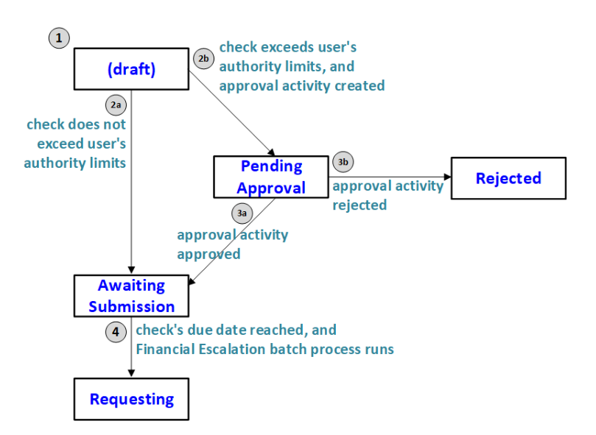

1. While a check is being created, it is in a draft state with no status.
2. Once the check is created, the Claim Center checks the corresponding user's authority limits.
   1. If the check does not exceed any of the user's authority limits, the check moves to "Awaiting submission".
   2. If the check does exceed any of the user's authority limits, the check moves to "Pending Approval". Claim Center creates an approval activity and assigns it to the appropriate approving user.
3. If a check is "Pending approval", the approving user can take the following actions.
   1. They could approve of the activity, which causes the check to advance to "Awaiting submission".
   2. They could reject the activity, which causes the check to move to "Rejected".
4. Once a check reaches "Awaiting submission" it remains in this state until its due date. Once the due date is reached, the Financial Escalation batch process submits the check to the downstream system and advances the check's status to "Requesting".

**Void:**

**A void** cancels a check before it is cleared typically for mistakes like wrong payee or amount.

**Stop:**

A **stop** is used when a check has already been issued but is lost or suspected of fraud, and we need to prevent it from being cashed.

**13.Partial payment:**

A temporary, incomplete payment issued before the final claim settlement.

* To provide quick funds to the claimant (e.g., immediate repairs or medical bills).
* When the total loss amount is still being assessed.

**Example,**

* Claim: A policyholder’s car is damaged in an accident.
* Initial Estimate: $5,000 (partial repair cost).
* Partial Payment: Insurer pays $3,000 upfront to start repairs while waiting for a final estimate.
* Later: The remaining $2,000 is paid after final approval.

**14.Supplement payment:**

An additional payment issued after the initial settlement, typically due to:

* Newly discovered damage (e.g., hidden car damage).
* Underestimation of costs (e.g., medical treatment exceeds the initial estimate).

**Example,**

* Initial Settlement: $10,000 for a roof repair.
* Supplement: Contractor finds mold damage (+$2,500).
* Supplement Payment: Insurer approves an extra $2,500.

**15. What is Financial Hold?**

Financial Hold is a feature used to temporarily prevent payments or other financial

transactions from being processed on a claim. It acts as a control mechanism to ensure that

certain conditions are met before any money is disbursed. Financial Holds are often used in

situations where additional verification, approval, or investigation is required

**17. Assignment Logic:**

Assignment logic in Guidewire Claim Center determines how entities (such as claims,

exposures, activities, or contacts) are assigned to users or groups for handling. It ensures

efficient distribution of tasks, workload balancing, and proper routing based on predefined

rules and criteria.

**Types of Assignment Logic:**

1. **Manual Assignment**:

* The user assigns tasks or entities manually to specific users or groups.
* Example: An adjuster manually assigns a claim to a colleague with relevant expertise.

1. **Automatic Assignment**:

* The system assigns entities based on predefined rules and logic.
* Types:
  + **Round-Robin Assignment**: Distributes tasks evenly among a set of users.
  + **Load-Based Assignment**: Assigns tasks based on user workload or capacity.
  + **Skill-Based Assignment**: Matches tasks to users with specific skills or expertise.
  + **Role-Based Assignment**: Assigns tasks to users based on their role in the organization.

**Assignment Methods:**

1. **Group Assignment**:
   * Assigns tasks to a specific group, from which members can pick up work.
   * Example: A claim is assigned to the "Auto Adjusters" group.
2. **User Assignment**:
   * Directly assigns tasks to individual users.
   * Example: A bodily injury claim is assigned to a senior adjuster.
3. **Dynamic Assignment**:
   * Uses dynamic rules to assign tasks based on conditions such as location, claim type, or severity.
   * Example: A claim with high severity is automatically assigned to a manager.

**18. FNOL:**

FNOL (First Notice of Loss) is the event in which the insurer is informed of a potentially

covered loss.

**Draft claims and open claims:**

During the FNOL process, the claim is first created. The claim passes through two states:

draft and open.

* A draft claim is a claim that has been saved to the Claim Center database, but there is not yet enough information for the claim to enter the adjudication process. Draft claims are not assigned to any user.
* An open claim is a claim that has been saved to the Claim Center database with enough information to enter the adjudication process. Once a claim becomes open, it is assigned to an adjuster. (Open claims are often referred to simply as "claims".)

**19. What are the types of transactions?**

The transaction is the basic unit of all financial operations in Claim Center. The Transaction

object is the main financial entity in Claim Center. It has the following subtypes:

1. Reserve
2. Payment
3. Recovery
4. Recovery Reserve

**1.Reserve:**

A **reserve** refers to the amount of money set aside by an insurance company to cover future claims and associated expenses. Reserves are a critical component of an insurer's financial management, ensuring that they have sufficient funds to pay out claims as they arise.

**2.Payment:**

Records of all claims related to disbursements made to satisfy the claim, in part or whole.

**3.Recovery:**

A recovery is a transaction that accounts for money received by the insurer to help settle a claim. Recoveries can come from a variety of sources. Among them are:

**Salvage:**

Salvage refers to the process of recovering value from damaged or destroyed property (e.g., vehicles, equipment, or other assets) after a claim has been paid. Salvage is typically associated with property and auto insurance claims, where the insurer takes ownership of the damaged property (if it is deemed a total loss) and attempts to sell it to recover some of the claim costs.

**Example,**

Imagine you have car insurance, and you get into an accident. The car is so badly damaged that it’s considered a total loss (meaning it can’t be repaired for a reasonable cost).

**You file a claim**: You report the accident to your insurance company.

**Assessment**: The insurance company looks at your car and says, "This car is beyond repair. It is a total loss."

**Insurance Payout**:

* Your car was worth **$10,000** before the accident.
* You have a **$500 deductible**, so the insurance will pay you **$9,500**.

**Salvage**:

* The insurance company sees that even though the car is totaled, it can still be **sold for parts**. They estimate the salvage value (how much they can sell the car for) to be **$2,000**.

**Final Payout**:

* The insurance company **deducts the salvage value** from your payout.
* So, instead of paying you the full **$9,500**, they pay you **$7,500** and **keep the car** (to sell for parts).

**Subrogation:**

Subrogation is the process where an insurance company, after paying for a claim, seeks to

recover the money it paid out from a third party who is responsible for the loss or damage.

**Example:**

1. **Accident Happens**:  
   You are driving, and another driver (Driver B) runs a red light and hits your car.
2. **You File a Claim**:
   * You have **auto insurance** with Company A.
   * You file a claim with **Company A** to repair your car.
   * **Company A** pays for the repairs, which cost **$5,000**.
3. **Subrogation Process Starts**:
   * Since **Driver B** was at fault for the accident, **Company A** believes they can recover the $5,000 they paid you from **Driver B** or their insurance company.
   * **Company A** will now **take legal action** against **Driver B’s insurance** (or Driver B directly) to **get back the $5,000** they paid out.
4. **Recovery**:
   * If **Driver B’s insurance** accepts responsibility, they will pay **Company A** the **$5,000**.
   * If **Driver B** doesn't have insurance or refuses to pay, **Company A** might take legal action to recover the money.
5. **You Don’t Lose Your Payout**:
   * **You already got paid** by **Company A** (the $5,000).
   * **You don’t need to repay** anything if Company A is successful in recovering the money from Driver B's insurance.

**4.Recovery Reserves:**

Recovery reserves are estimates of how much money might be recovered from others in settling the claim. Estimates of how much money might be recovered from others while settling the claim.

**Deductibles**:

A deductible is a specific amount of money that a policyholder (the insured) must pay out of pocket before their insurance coverage kicks in to cover the remaining costs of a claim.

**Indemnity:**

Indemnity is the amount paid directly to the claimant (or on their behalf) to compensate for actual loss or damage caused by the covered event. Repair cost of a damaged car: ₹1,00,000.

**Expense-Legal:**

Costs that are specifically related to legal actions or services involved in handling the claim. ₹20,000 to a legal firm defending a liability claim. ₹5,000 court fee for contesting a claim.

**Expense-Other:**

Non-legal claim handling costs — any operational or third-party costs that are not indemnity or legal in nature.

|  |  |
| --- | --- |
| Reserve Lines | ClaimCenter uses reserve lines to track specific costs that are related to a claim. A reserve line represents the categorization or coding of a transaction, and is a combination of exposure, cost type, and cost category. |
| Reserves | Estimates of how much money might be needed to satisfy future claim liabilities and associated costs. |
| Transactions | Modify the amount of money in a reserve line. A reserve transaction modifies the amount of money set aside for the reserve line. A payment transaction moves money from a reserve line to a payment to a claimant or other party. |
| Payments | Records of all claim related disbursements made to satisfy the claim, in part or whole. |
| Checks | A single transfer of money from one or more reserve lines to one or more individuals or organizations. |
| Recovery Reserves | Estimates of how much money might be recovered from others while settling the claim. |
| Recoveries | The receipt of claim costs from others, including salvage and subrogation. |